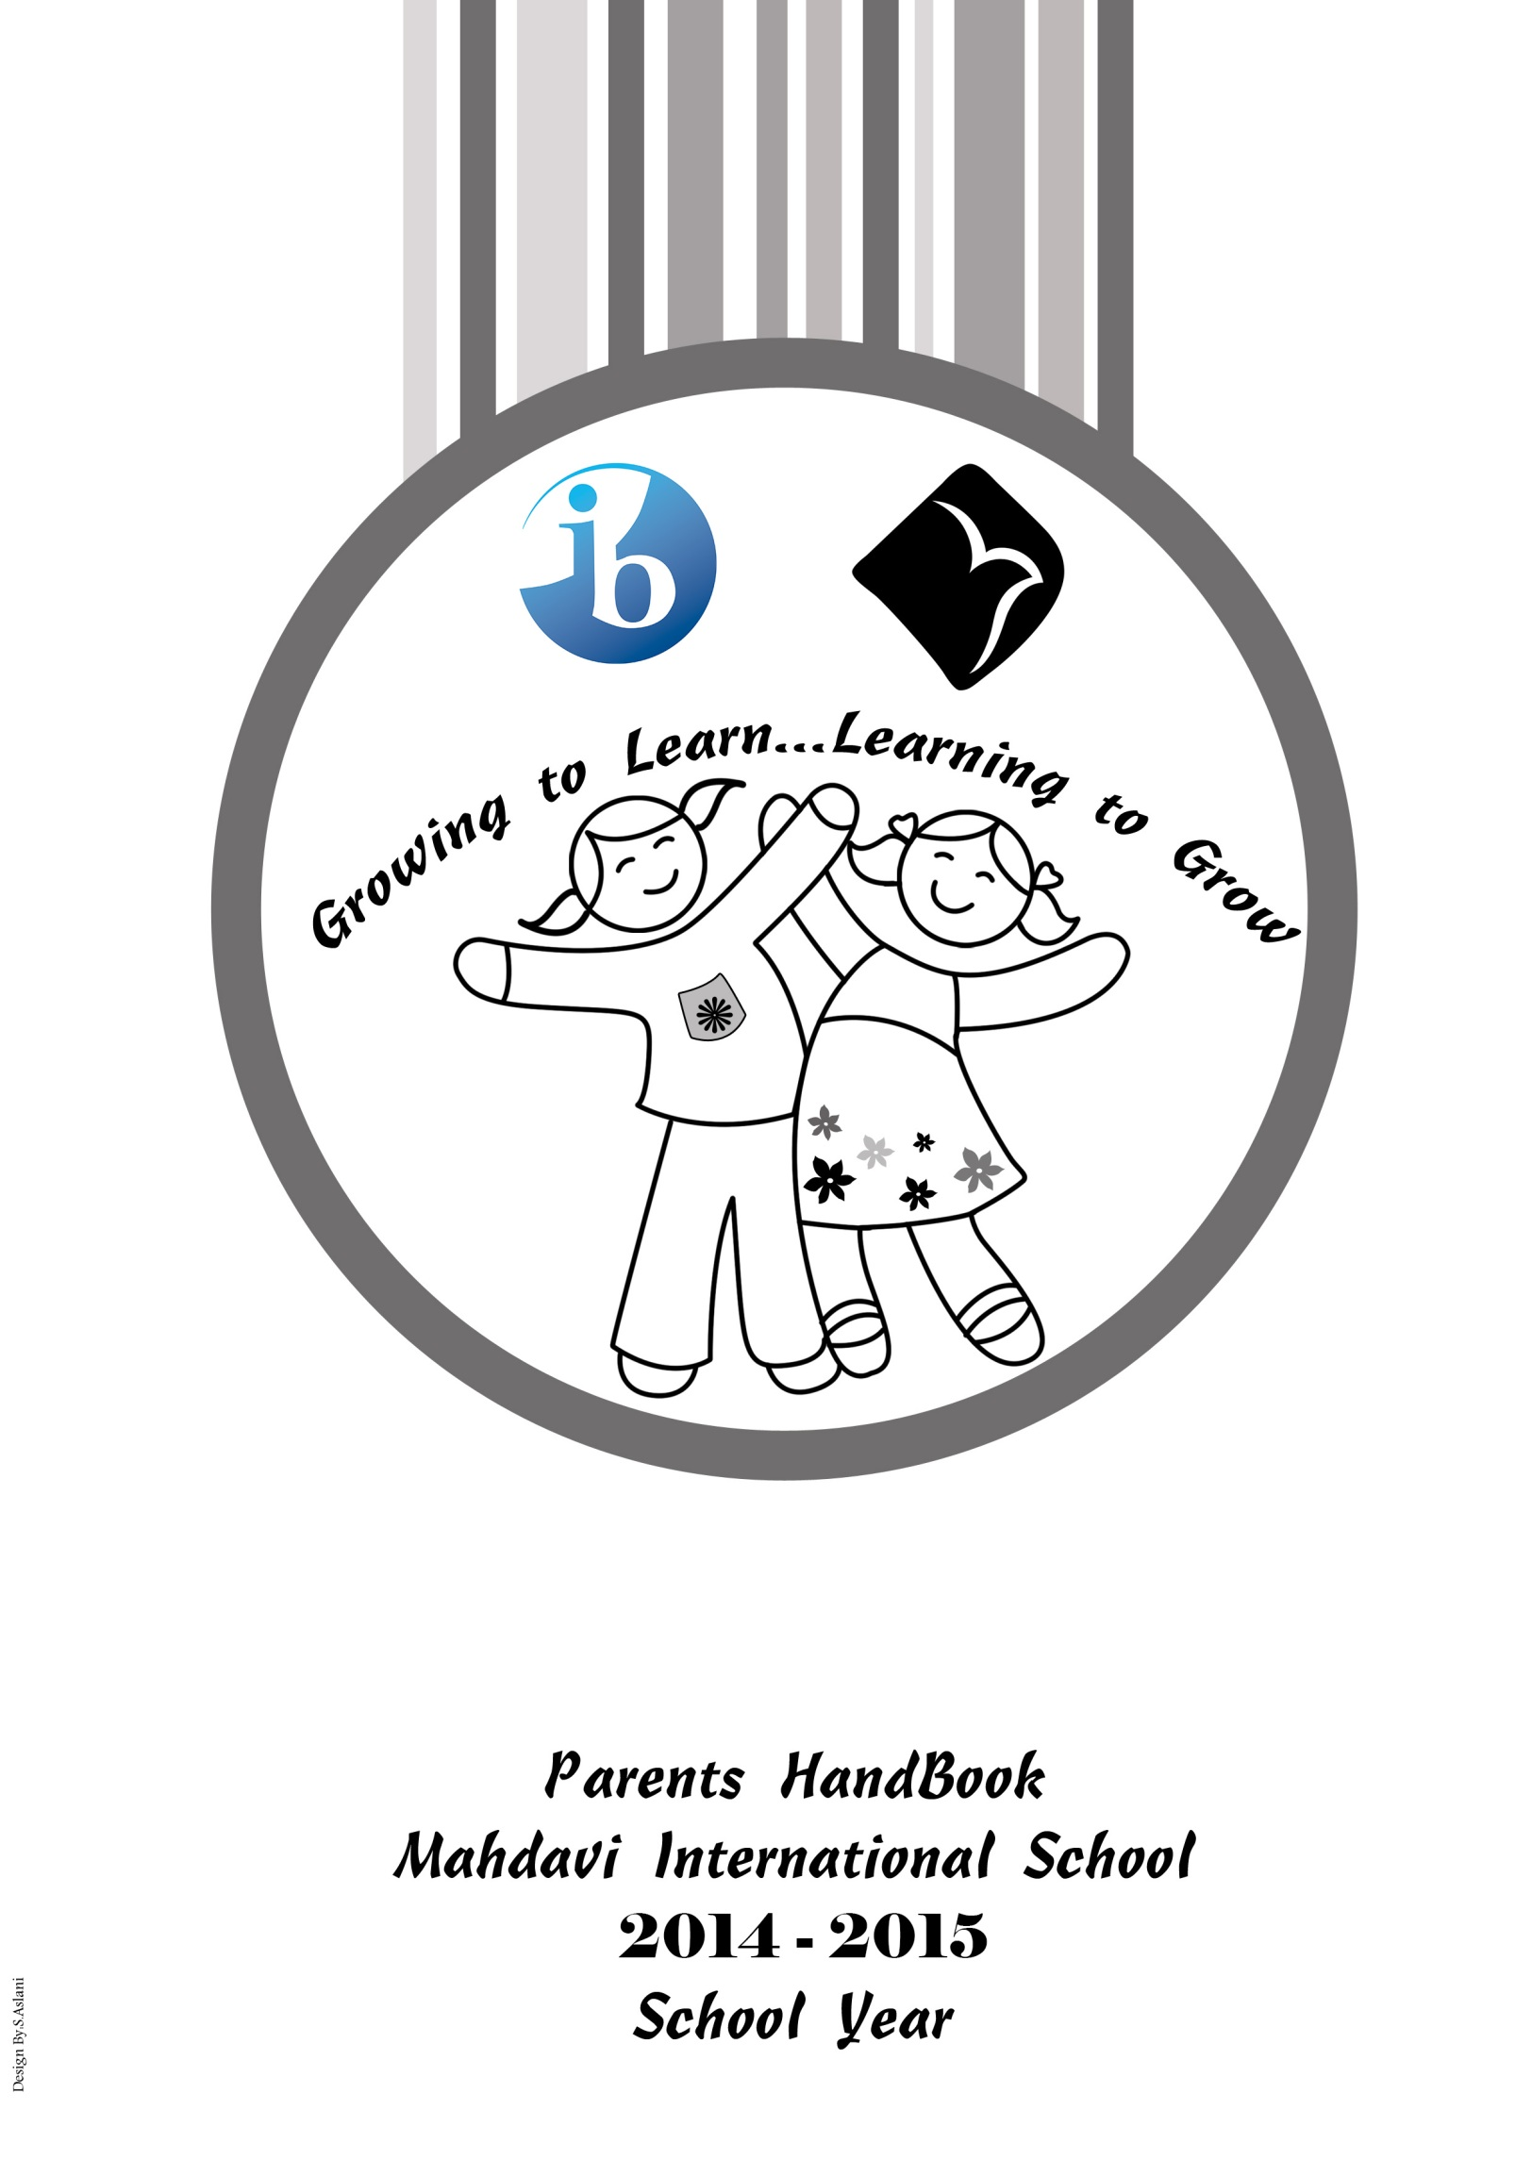

**2022-2023**

**Contact Information**

**Shahid Mahdavi International School**

**Kouh‐Daman, Mina, Zanbagh**

**Ejazi, Zafaranie St**

**Tehran, Iran**

**Phone: 98 21 22435550**

**Ext. 190 (PYP)**

**Ext. 145 (MYP)**

**Website: www.mahdavischool.org**

**Via**

**Moodle**

**General Information**

With many nationalities represented, our blended diversity creates a truly international educational experience where multicultural students learn and play in English all day, every day.

We aim to cultivate the internationalism represented in our school community by providing equal educational opportunities for students from diverse racial, ethnic, social‐class, and cultural groups. Our commitment to one another—whether faculty, teacher, students, or parents—creates within SMIS a strong sense of belonging and connectedness.

SMIS is an IB PYP-MYP-DP school for kindergarten up to grade 12

**ACADEMIC PROGRAMS**

PYP is the elementary component of the highly respected International Baccalaureate Organization (IBO) and SMIS is an authorized IB PYP-MYP-DP school.

**PYP Overview**

The PYP is the elementary component of the world renowned International Baccalaureate (IB).

The PYP provides the curriculum framework for all students from KG1 to grade 6. This transdisciplinary approach to teaching and learning ensures that students matter essential knowledge, skills, concepts and attitudes. A comprehensive and artfully designed unit of inquiry integrates the traditional core subjects of language arts (reading, writing, listening, speaking), mathematics, science and social studies with specialist subjects’ areas such as Music, Art, Physical Education, Library and Technology. The PYP focuses on the heart as well as the mind and addresses social, physical, emotional and the cultural needs in addition to the traditional academic subjects. The program provides opportunities for the learners to construct meaning, principally through concept‐driven inquiry.

**INQUIRY**

Inquiry is the process initiated by the learner or the teacher which moves the learner from her current level of understanding to a new and deeper level of understanding through:

•Exploring, wondering and questioning

•Elaborating on solutions to problems

•Researching and seeking information

•Collecting data and reporting findings

•Deepening understanding through the application of a concept or rule

**PYP TRANSDISCIPLINARY THEMES**

Within the PYP, all students from Reception to Grade 6 study six units of inquiry within a given academic year. Each unit is directly linked to a transdisciplinary theme. These themes have meaning for individuals from different cultures and incorporate both local and global issues in the content. The six themes are:

•Who we are

•How the world works

•Where we are in place and time

•Sharing the planet

•How we express ourselves

•How we organize ourselves

**IB LEARNER PROFILE**

The Learner profile is a list of ten attributes. Through thoughtful teaching and careful modeling, SMIS aims to use these attributes to develop the concept of international mindedness in all students. The 10 attributes of the IB Learner Profile are:

**Faithful, Inquirer, Thinker, Communicator, Risk‐Taker, Knowledgeable**

**Caring, Open‐minded, Balanced, Principled, Reflective**

**ASSESSMENT**

The PYP stresses the importance of both student and teacher self‐assessment and reflection. Teachers use a diverse array of assessment tools and strategies and assess student learning on an on‐going basis. Opportunities are provided for students to consider their progress in relation to the attributes listed in the PYP student profile. Student and teacher observations and anecdotal records of performance are included in each child’s portfolio of selected work that is shared with parents at key points in the academic year.

Read more about the IB PYP in the document, a basis for Practice: the Primary Years Program at <http://www.ibo.org>

**ENGLISH LANGUAGE USAGE**

English is the language that unites SMIS as a community. Parents’ expectations are that their

children will become fluent in English. Fluency is defined as the ability to comprehend, read,

write, and speak English spontaneously with ease.

Students are expected to:

1- View English as the language that unites our campus.

2- Use English in their classrooms to develop their listening, speaking, reading and writing

Skills thereby maximizing learning.

3- Help create a risk‐free accepting environment in the classroom and across the campus that fosters the learning of English.

4- Be sensitive to the ramifications of not using English in class (i.e., the loss of time to practice the language; exclusion of others who do not share the language spoken).

5- Be aware of the impact of not using English in on‐campus interactions and off‐campus

School‐sponsored activities where non ‐ speakers of the language are present.

**Daily Schedule**

**School Times**

**KG:**

**8:15 am to 3:20 pm**

**Grade 1 to Grade 5:**

**8:15 am to 3:30 pm**

**Responsibilities**

Teachers and the administration of Mahdavi International School expect students to come to school prepared to learn. When circumstances prevent a student from concentrating on learning, the staff of SMIS will seek ways to help the student. However, it is expected that the student will cooperate and want to improve her performance or behavior. Behavior expected of all students includes:

1. Respect for the rights of other students.

2. Respect for the authority of all SMIS staff.

3. Respect for school property.

4. Responsibility for being on time for class.

5. Being prepared for class.

**ATTENDANCE**

The school's instructional program is based on the assumption that students will attend school regularly. Daily class attendance is a condition for coursework and general academic progress at the school. Student must attend **at least 85% of the instructional days** designed in the school calendar. The school asks that students be absent only for those matters that cannot **be arranged outside of school hours**. Consistent and regular attendance enables students to keep up with classroom learning expectations and enjoy fully the varied classroom activities.

**ABSENCE**

If a student is absent for any reason she must have a reason entered in the Student Agenda and signed by a parent or guardian. Parents are also expected to call and inform the school on the morning of each absence. In the event of a planned absence, parents are expected to inform the school in **writing** of the planned absence. If leave has to be taken during the school year, parents should notify the school in good time (5 to 10 days ahead of time). While a student’s teacher will make every effort to indicate what work will be covered during the period of absence, it is the **student’s responsibility to make up** this work. The student is expected to return the **completed work** upon return.

**PUNCTUALITY**

SMIS expects all students and staff to be on time. **Punctuality** is a mark of good manners and students are expected to arrive at school and for their lessons **on time**.

**EXTENDED LEAVE**

Unless an emergency, the school strongly encourages parents to plan all family vacations during regularly scheduled school breaks so that children do not miss school. When students are absent from school for an extended time they miss important instructional and educational interactions with teachers and classmates. Teachers are not required to prepare additional supplemental materials for the students to make up except in the case of **extended illness or a family emergency.**

**EARLY WITHDRAWAL**

When a student is withdrawing from school, at least one month's notice (unless it is due to an emergency) should be given if the student wishes to receive her transfer documents the day she leaves. All departments of the school are then notified of the student’s departure. When all obligations have been met, the student's school records are released.

**REPORTS AND GRADING**

Report cards are issued four times a year. Parents receive formal progress reports two times per school year. These are also supplemented with Parent‐Teacher Conferences at least twice a year and on an as‐needed basis.

● **P.E. Uniform**

All students must bring their P.E. kit, a towel and paper toilet to school (or wear it on P.E. days) on the required days (parents are asked to check their child's timetable).

Sports/running shoes that fully cover and support the foot. The Ballet kit is to be worn by

Students taking ballet. Students participating in swimming must have their own swimming suit, swimming cap and towel. Students not suitably attired will not be allowed to participate.

● **Jewelry**

The school advises that students do not wear valuable jewelry to school

● **Hair**

Should be **kept neat and tidy** at all times. If long, it should be **tied back**. Students are advised not to color their hair

● **Nails**

Should be kept clean and short, as the students play many contact sports.

**WATER FOR DRINKING**

Students are expected to bring water bottles with them to school each day. Bottled water is available in the lunch room for children to drink. Children may refill their water bottles as needed. For hygiene purposes, please label your child’s water bottle and remind them that they should not share their bottles with their friends. Cups will be available only if your child forgets her water bottle.

**LIBRARY**

SMIS has a growing library, which plays a central role in the school‐learning program,

providing a good range of reading material for students. There are both reading and reference books used for class time and for recreational reading. Children are encouraged to borrow books each week. Parents are asked to help read library books to their children and remind them to treat books with respect.

Your child’s class teacher will be happy to go over the “Library Book Rules” with you. We are

always happy to receive donations of suitable books for the library. The school’s library Policy on missing or overdue books is that the borrower is reminded verbally within the first week; a written notice is issued the second week. The librarian will send a written notice to parents. No other material will be issued to the borrower until all materials have been returned. Missing items will be deleted from the library catalogue

**HOMEWORK**

Homework forms an important part of a student's education since it reinforces the work covered during lessons. For students at SMIS, homework is an expectation, although the amount and nature of the homework will vary according to the age and grade of the student. The school provides homework diaries (Student Record Book) for students from kindergarten through Grade 6 to assist with the organization of assignments. Homework assignments and due dates are recorded each day and should be checked and initiated by parents/guardians. The Student Record Book and Mahdavionline.org Moodle (School site) can be useful for the direct communication between home and school and should be checked daily.

It is recommended that parents/guardians remain aware of their children's homework, coursework and project commitments. Helping ensures that adequate time is set aside and that there is a quiet place for each child to work.

Children have a Student Record Book that has a “Homework Area.” Homework assignments are listed by the teacher in the “Homework Board.” Students must copy their assignments and the teacher will initial it in the appropriate column. Parents must initial the correct column when the homework is completed.

**How long should it take?**

Rough guidelines are:

|  |  |
| --- | --- |
| **Grade Level** | **Time of Homework per day** |
| Kindergarten | parents reading |
| Grade 1 | 25-30 minutes + reading |
| Grade 2 | 35-40 minutes + reading |
| Grade 3 | 45-50 minutes + reading |
| Grade 4 | 60-80 minutes + reading |
| Grade 5 | 70-90 minutes + reading |
| Grade 6 and above | 80-100 minutes + reading |

What form can assignments take?

● Handwriting practice, Inquiry tasks, Reading (silent/oral),

● Review (spelling, number facts, test material, etc.)

● Skill games

● Creative writing

● Oral assignments

● Continuation of classroom activities

● On line Projects

Please consult your child’s teacher if your child needs more time for completion of homework on a continual basis.

**CONSEQUENCES FOR LATE or INCOMPLETE HOMEWORK**

Students are expected to satisfactorily complete and submit on time all homework assignments. Children are encouraged to be responsible and well organized. At the beginning of the academic year, teachers will share homework expectations and consequences with all students. These consequences are standardized from Kindergarten to grade 6 so that expectations remain consistent from teacher to teacher and from grade level to grade level. It is expected that all parents support.

**READING AT HOME**

In addition to daily homework assignments, all students are expected to read at home on a daily basis. This includes both reading aloud to parents and reading silently. Building reading stamina (the ability to read for longer periods of time) positively impacts student learning. Parents are also **strongly encouraged to read aloud to their children**. This provides a model of good reading at home, promotes interest in reading, and helps foster a love of reading.

**FIELD TRIPS**

Field trips are an integral part of the curriculum and provide extended learning activities outside the classroom for students in all grade levels. These are day trips for the students. The field trips are mandatory and should be attended unless the child is ill or some other unavoidable reason.

Many activities ‐ Language Arts, Geography and Science projects are based around these trips. Above all these trips teach our students independence, social behavior, expectations, and pride in representing our school. Parents will always be informed when their child is attending any trip or function off school grounds. A notice will be sent home advising of the date, place, return time, and reason for the trip. Parents should be given about one week notice for any field trip. Current education philosophy recognizes the desirability of using the total community environment as a learning laboratory. To this end, teachers may schedule field trips for their classes. These trips, always arranged for their educational value, enable students to see people at work and serve to broaden the students’ total educational experiences. Every effort will be made to assure both the appropriateness of any trip away from school and the reasonableness of the trip. For this reason, all field trips must have the approval of the principal. Before a student can go on a field trip, a signed permission form from the parent must be on file in the office. Verbal permission is not accepted. A field trip is defined as any planned activity that necessitates the students leaving the school grounds during the instructional hours from 9:00a.m.‐3:30 p.m. To ensure the safety of students, they must leave and return to campus with their teacher on the school bus. Parents may be asked to serve as volunteer chaperones on these trips when needed. Parents will be informed of any activity where their child will leave school grounds.

**AFTER SCHOOL ARRANGEMENTS**

If your child is to go home with a classmate after school, BOTH THE HOSTING AND VISITING

STUDENT SHOULD BRING NOTES FROM THEIR PARENTS INDICATING THE PLANNED VISIT AND TRANSPORTATION PLANS. No student will be permitted to ride home after school with anyone other than her parent/assigned, drivers or school bus unless the child brings a note from her parent, requesting such. Students are not allowed to leave the school campus during the school day without an appropriate adult.

**ATTENDANCE/LEAVING SCHOOL**

Students in elementary school who are absent more than thirty days during a year shall be referred to the PYP Coordinator and the Principal, who shall determine if the student should be retained. They will also review any additional educational experiences that the child might have received during the absences as they make their determinations. A student who leaves school for any reason during the day is counted absent for that day. Students may leave with a parent for dental or doctor appointments with prior notice to the teacher. If possible, these appointments should be made after school hours.

**If it is necessary for a parent to take her child from school early for a medical appointment, please come to the school’s lobby.** Office personnel will call your child from the classroom after you arrive. If the student returns to school, she should report to the receptionist for re‐admission.

**School transportation services RULES**

•Show respect at all times for school drivers, staff members, and students

•Remain properly seated until the car or van comes to a complete stop at

your stop.

•Talk politely and quietly

•Keep the car or van clean. Throw trash in the waste basket or keep in your backpack until home or arrival at school.

• Do not open the windows without permission.

• keep body parts inside the car or van or school service.

•Look both ways if crossing the street after the car or van pulls away.

**Car or Van DISCIPLINE**

**While there are adults on the van, they may get on or off before or after all children depending on the route.**

The policy of SMIS on school bus discipline is as follows:

1. Students misbehaving on a bus will be reported by the driver to the principal. A letter will

Immediately notify the parent that this report was received. A conference will be scheduled with the student and the principal.

2. This letter will also advise the parent that should the principal, in the course of the school

year, receive a second complain, the student will be denied the privilege of riding the bus

for a period. Parents are responsible for providing transportation during this period.

3. Any additional report of misconduct will be handled in a similar manner. The period of removal from the bus will be increased with each report.

4. An offense will be any act that would distract the attention of the driver or jeopardize the safety of the students or vandalize school property.

**DISCIPLINE**

Most laws specifically give teachers and principals the right to use reasonable force to maintain discipline in the school. Please feel free to discuss with your child’s teacher your feelings concerning discipline in the classroom.

**EARLY DISMISSAL/ CHECK OUT FOR THE DAY**

Requests for early dismissal should be submitted in writing to the child’s teacher and principal. We will call the classroom when you arrive to sign your child out in the office. Please avoid requesting dismissal between 3:00 to 3:30 p.m., as this is a very busy time in the office and the classroom. Note: At the beginning of each school year, you will need to fill out information cards and have signatures on the card for anyone who has permission to pick your child up from school.

**EMERGENCY HELP INFORMATION**

Please give your child’s teacher the name and phone number of a relative, neighbor, or friend who can be contacted in case of an emergency when you cannot be reached. If this situation changes during the year, please notify the office.

**HEALTH GUIDELINES**

Please be sure to inform your child’s teacher if your child has a chronic illness or any other health issue and if there are any special measures or activity restrictions that will be necessary for her safety at school. Please keep your child at home and consult your doctor if she has any of the following symptoms, which may indicate the onset of a communicable disease:

● Fever

● Watery eyes, discharge from eyes

● Sore throat with fever

● Cough with fever

● Skin rash or spots

● Nausea, vomiting, diarrhea

Your child should be fever free, without use of aspirin or fever reducing medications, for 24 hours before returning to school. If a child has been sent home with a fever, they must remain home for at least 24 hours before returning to school. If your child has an infectious disease, she should receive one full day’s worth of antibiotics before returning to school.

Colds are most contagious in their earliest stages. Please encourage good hand washing to reduce the spread of germs.

**INCLEMENT WEATHER**

Now is the time to plan with your child what to do in case of rain at dismissal time or early dismissal because of snow or ice. All students are expected to be outdoor for breaks and after lunch if the weather is suitable. No student will remain indoor unless there is a medical reason or disciplinary measures are in effect. Unsuitable weather is weather that is too cold for outdoor play (‐10c), weather that is too wet .If there is a chance of heat or sunstroke than children and staff must remain in shaded areas, but may still go outside. If no shade is available or the temperature rises beyond +35c all children and staff must remain inside. Some children become very concerned if their usual patterns are disrupted; this is particularly true for some of our younger children. If school needs to be closed early for any reason, you will be called and informed. Please make sure we have your correct current information and emergency contact number.

**LATE ARRIVAL**

If your child is late to school, please bring her to the office, she will receive a late note.

**LOST AND FOUND**

The Lost and Found is located in the lobby. Please check it periodically, as it will be donated to non‐profits at the end of each term. Please label everything for the students.

**CELEBRATIONS:**

SMIS policy states that all activities that take place within the school during a school day should be based on a learning experience for the children and cannot be approved if they are purely for entertainment or for birthday recognition.

**Please ask your child’s teacher for permission to bring refreshments on your child’s birthday. Additionally, seek permission to serve “home baked goods” to the class.**

**SNACK TIME**

Your child’s class will set aside time during the day for a snack break at 9:40 to 9:55 and a 2nd break at 12:05 to 13:10. Snacks brought from home should be of nutritional value. Fruits, vegetables, cheese, and crackers, etc. are encouraged (Soft drinks/sodas are not permitted at any time.)

**TRANSFERS**

Except for emergencies, the parents or guardian of a student transferring from Shahid Mahdavi International School should notify the teacher and office at least one‐month prior to the last day of his/her attendance. All textbooks and library books must be returned, along with all fees and transportation charges must be paid in full, before any reports or letters will be released to the parent or new school.

**ELECTRONIC ITEMS and CASH at SCHOOL**

Unless absolutely necessary, please do not send mobile phones to school. If necessary, they must be turned off during school hours. Personal electronic equipment, such as IPods, laptops, MP3players, etc. are discouraged, as the school cannot be responsible for any theft, damage or lost items. It is unnecessary for children to carry a large amount of cash with them to school. At times Juice, iced tea, or a small snack may be available for purchase when a class has engaged in a special project. When this occurs parents should you be informed be forehand. Otherwise there is no need for children to carry cash to school.

**Coats, boots etc**

Each student is assigned a space that has hooks for their coats and back packs. This space is intended for this purpose only. This space is suitable for shoes/boots and an umbrella but does not accommodate anything else. The school cannot be held responsible for lost or stolen items. No open food or drink containers should be stored in this space.